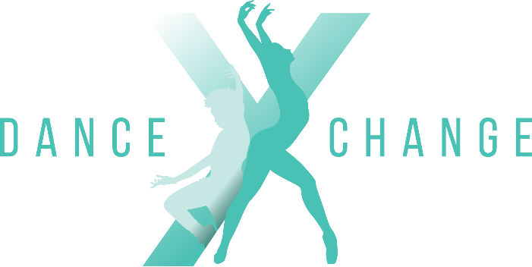

INSPIRING GROWTH THROUGH DANCE
200 Smit Street Fairland
info@dancexchange.co.za
Jacquie 083 295 4540 / Bryanne 079 895 6175

PARENT/GUARDIAN INDEMNITY & CONSENT FORM
DanceXchange is committed to providing a safe, positive and professional environment in which dancers can learn, train and enjoy their passion for dance.
Dance involves physical activity and carries inherent risks, including, but not limited to, muscle strains, sprains, bruising, falls, collisions, overuse injuries and other physical injuries. By allowing your child to participate in DanceXchange classes, rehearsals, performances, competitions and related activities, you acknowledge and accept these inherent risks.
1. ASSUMPTION OF RISK
I, the undersigned parent/guardian, acknowledge that dance is a physically demanding activity and that participation may involve risks of injury, including serious injury, including serious injury, sprains, fractures and, in rare cases, more severe harm.
I understand that injuries may occur even when appropriate instruction, supervision, warm-ups and safety measures are provided.
I voluntarily permit my child to participate in DanceXchange activities and accept the ordinary and inherent risks associated with dance and physical activity.
2. HEALTH & MEDICAL INFORMATION
I confirm that, to the best of my knowledge, my child is physically able to participate in dance activities.
I undertake to inform DanceXchange of any medical condition, injury, allergy, medication, physical limitation or other relevant health information that may affect my child's ability to participate safely.
I understand that it is my responsibility to ensure that DanceXchange is provided with accurate and up-to-date medical information.
DanceXchange must be notified immediately of any injury or medical condition that may affect a dancer's participation.
3. INJURIES, MEDICAL TREATMENT & COSTS
I understand that DanceXchange teachers and staff are not medical practitioners and are not responsible for diagnosing, treating or rehabilitating injuries.
If my child sustains an injury or becomes unwell while participating in a DanceXchange activity, I authorise DanceXchange staff to take reasonable steps to ensure my child's immediate safety and, where reasonably necessary, to arrange appropriate emergency medical assistance.
I understand and agree that all medical consultations, emergency treatment, physiotherapy, rehabilitation, medication, specialist treatment and any other medical or related expenses arising from an injury or illness are the responsibility of the parent/guardian and/or the dancer's medical aid or insurance, and not DanceXchange.
Where possible, DanceXchange will contact the parent/guardian as soon as reasonably practicable in the event of an injury or medical emergency.
4. INDEMNITY
To the fullest extent permitted by South African law, I indemnify and hold harmless DanceXchange, its owners, directors, teachers, instructors, employees, assistants and authorised representatives against claims, losses, costs or expenses arising from my child's participation in dance activities, save to the extent that such claim, loss, cost or expense arises from the gross negligence of DanceXchange or the persons named above.
I acknowledge that DanceXchange cannot guarantee that a dancer will not sustain an injury while participating in dance activities.
5. TEACHER & STAFF RESPONSIBILITY
I understand that DanceXchange teachers will take reasonable steps to provide appropriate instruction, supervision and a safe training environment.
I acknowledge that dancers are expected to follow all teacher instructions and studio safety rules.
I understand that a dancer who deliberately ignores instructions, attempts movements without permission, behaves recklessly or engages in unsafe behaviour may increase their risk of injury.
6. FITNESS, WARM-UP & PARTICIPATION
Dancers are expected to participate responsibly in warm-ups, conditioning and exercises appropriate to their level.
A dancer must immediately inform their teacher if they experience pain, dizziness, illness or discomfort during a class or activity.
No dancer should be forced to perform a movement that they are physically unable or medically advised not to perform.
DanceXchange reserves the right to restrict or suspend a dancer's participation where a teacher reasonably believes that continued participation may place the dancer or others at risk.
7. PRE-EXISTING & UNDISCLOSED CONDITIONS
I understand that pre-existing injuries or medical conditions may affect my child's ability to participate safely.
I accept responsibility for informing DanceXchange of any relevant condition or restriction before my child participates.
I understand that failure to disclose relevant medical information may increase the risk of injury.
8. PREMISES & PERSONAL BELONGINGS
I acknowledge that dancers and visitors enter the DanceXchange premises at their own risk.
I understand that DanceXchange is not responsible for the loss, theft or damage of personal belongings brought onto the premises, including phones, bags, clothing, jewellery and other valuables.
Dancers are expected to take reasonable care of their own belongings.

9. TRAVEL, PERFORMANCES & COMPETITIONS
Where DanceXchange dancers participate in performances, competitions, festivals, excursions or other activities away from the studio, I acknowledge that additional risks may arise, including travel, venue-related risks and participation in unfamiliar environments.
Where applicable, separate consent or indemnity documentation may be required for specific events, travel or activities.
10. EMERGENCY MEDICAL CONSENT
In the event that I cannot immediately be contacted, I authorise DanceXchange staff to obtain reasonable emergency medical assistance for my child where they believe this is necessary.
I understand and agree that any resulting medical costs remain my responsibility, subject to applicable law and the terms of my medical aid or insurance.
11. COLLECTION OF DANCERS
For the safety of all dancers, I undertake to notify DanceXchange in advance if someone other than myself or the usual authorised guardian will be collecting my child.
This includes an au pair, family member, friend or other authorised person.
DanceXchange reserves the right to request identification or confirmation before releasing a child to an unfamiliar person.
12. COMPLIANCE WITH STUDIO RULES
I confirm that I have read and agree to ensure that my child complies with the DanceXchange Studio Rules.
I understand that failure to follow studio rules or reasonable instructions may result in disciplinary action, including the dancer being asked to sit out of a class or, in serious or repeated cases, being asked to leave the studio.
13. PHOTOGRAPHS & VIDEO
I understand that DanceXchange may photograph or video dancers during classes, rehearsals, performances and events for legitimate studio, promotional and social-media purposes.
Parent/Guardian consent:
☐ I consent to my child's photograph/video being used by DanceXchange for promotional and social-media purposes.
☐ I do not consent to my child's photograph/video being used for promotional or social-media purposes.
14. ACKNOWLEDGEMENT
By signing below, I confirm that:
- I have read and understood this Indemnity & Consent Form, as well as the Rules & Attendance list
- I understand the inherent risks associated with dance and physical activity.
- I voluntarily give permission for my child to participate in DanceXchange activities.
- I have disclosed relevant medical or physical information to DanceXchange.
- I understand that medical, rehabilitation and treatment expenses are my responsibility.
- I agree to ensure that my child follows DanceXchange's studio rules and teacher instructions.

DANCER DETAILS
Dancer's Full Name: __________________________________________
Date of Birth: _______________________________________________
Identification number: _______________________________________________
Parent/Guardian Full Name: ___________________________________
Contact Number: _____________________________________________
Physical Address: _____________________________________________
Alternative Emergency Contact: _________________________________
Emergency Contact Number: ___________________________________
Medical Aid / Insurance (if applicable): ___________________________
Medical Aid Number (if applicable): ______________________________
Relevant Medical Conditions / Allergies / Injuries:

DECLARATION
I declare that the information provided above is true and accurate to the best of my knowledge.
Parent/Guardian Signature: ____________________________________
Parent/Guardian Name: ________________________________________
Date: _______________________________________________________
Dancer's Signature (if applicable): _______________________________
DanceXchange Representative: __________________________________
Date: _______________________________________________________

IMPORTANT: This form should be read together with the DanceXchange Studio Rules, registration terms and any event-specific consent forms. This document is intended to record the parent's/guardian's informed acknowledgement of risk and consent.

